Digi Strongswan test report

Topology

**Digi router**

**192.168.1.254**

**CISCO C3845**

**192.168.1.1**

**Hub**

PC

(For capture packet)

CISCO C3845 setting

Please refer to cisco_config.txt

Digi router setting

Step_1 –Setup interface

1. Create init_eth under /home/digi and copy the content of init_ethernet.sh to init_eth.
2. sh init_eth
3. Check the interface is up or not as following.

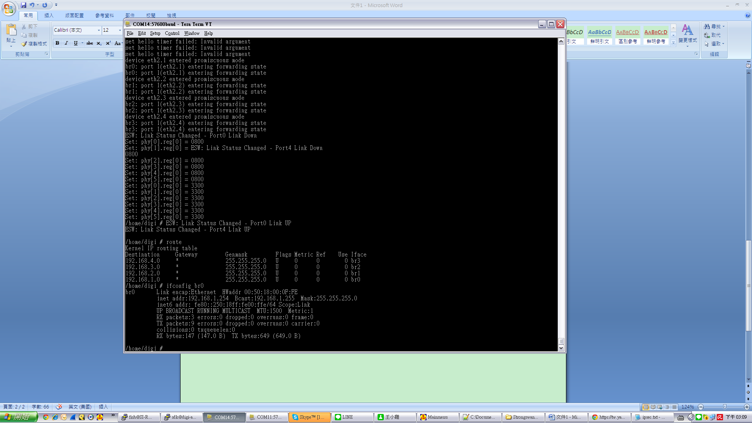

Step_2 –Setup ipsec

1. Execute lsmod to check crypto_k.ko is mounted correctly or not.

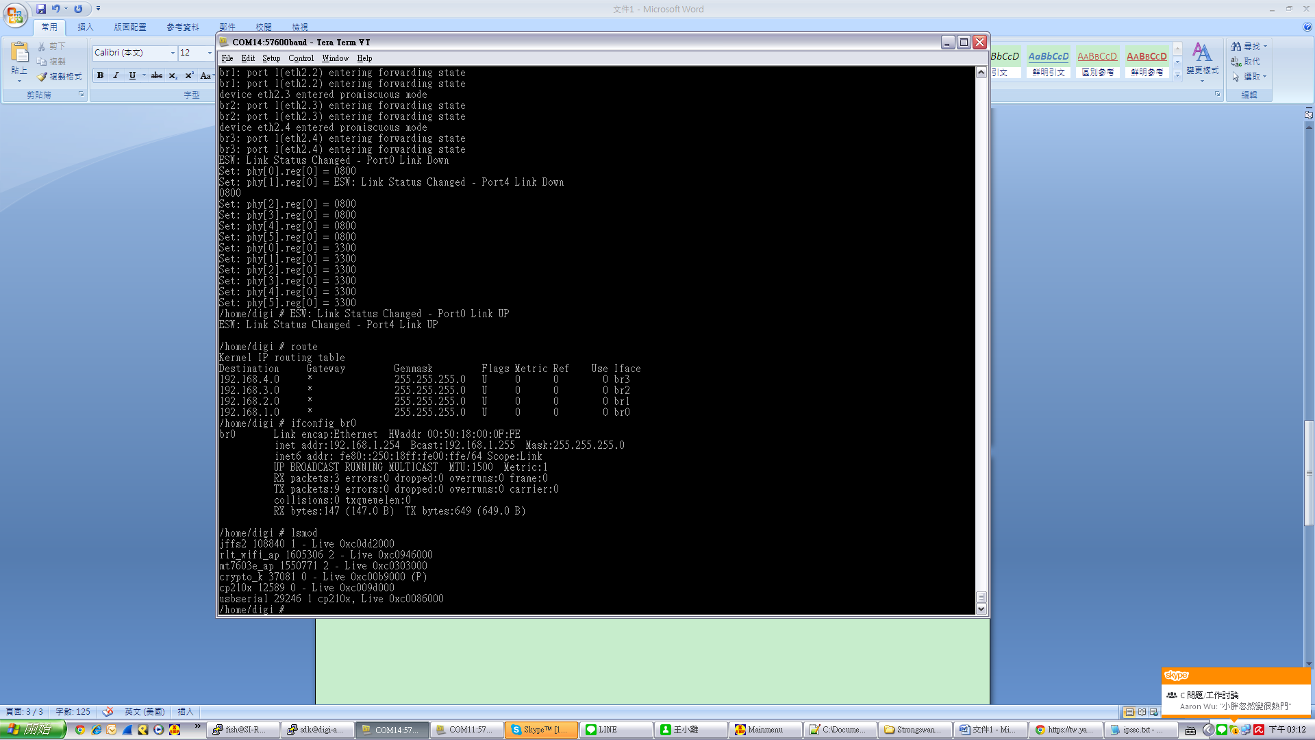

1. Create ipsec under /home/digi and copy the content of ipsec_for_cisco.txt to ipsec.
2. Create ipsec.init under /home/digi and copy the content of strongswan-init_20150916.txt to ipsec.init.
3. Create ipsec.test under /home/digi and copy the content of strongswan_test_20150916.txt to ipsec.test.
4. Excute ipsec.init to generate the ipsec configure file.
5. Excute sh ipsec.test to check the ipsec configure file. It will generate a file ipsec_test_result to record the test result.

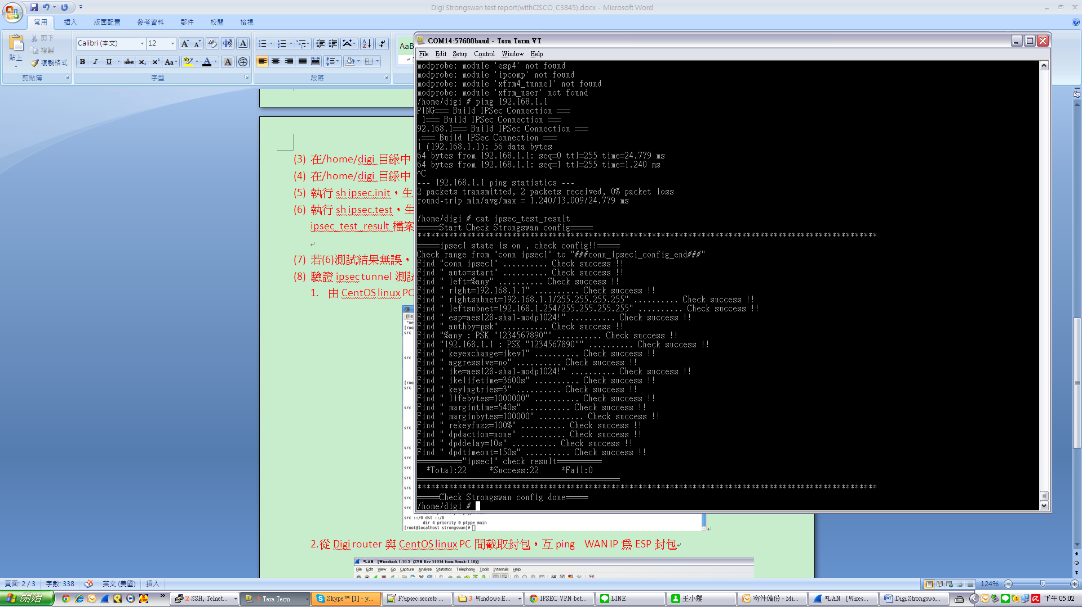

1. If the test result is correct without any fail. Execute _ipsec start to enable StrongSwan to establish the ipsec tunnel.
2. Verify the test result for ipsec tunnel as following.
3. You can see the ipsec tunnel is established successfully from Cisco.

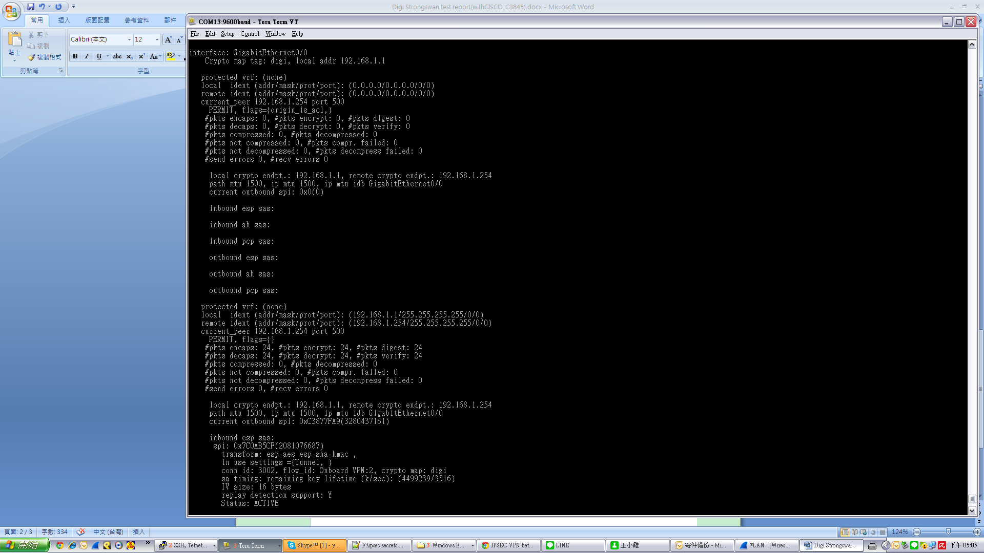

1. Ping to each other between Digi router and CISCO C3845 and verify ESP packets by capturing   
   packets via Wireshark.

